List of review journals
1. Advanced Engineering Materials
2. Journal of Materials Engineering and Performance
3. Composites Science and Technology
4. Materials Characterization
5. Next Materials
6. Surfaces and Interfaces
7. Carbon
8. Materials Today Communications
9. Optical Materials
10. Tribology International
11. Surface Review and Letters
12. Surface & Coatings Technology
13. Journal of Engineering Manufacture
14. Heliyon
15. Material Science and Engineering Technology
16. Part B: Journal of Engineering Manufacture
17. Silicon
18. Materials Research
19. Journal of The Institution of Engineers Serice C
20. Results in Materials
21. Journal of Materials Research and Technology
22. Advances in Materials Science and Engineering
23. Metals and Materials International
24. Physica Scripta
25. Applied Surface Science
26. Journal of Materials Processing Technology
27. Composites Part B
28. JOM: The Journal of The Minerals, Metals & Materials Society
29. Results in surface and interfaces
30. International Journal of Computer Integrated Manufacturing
31. Ceramics International
32. physica status solidi (RRL) Rapid Research Letters
33. Advances in Space Research
34. Sadhana
35. Advances in Materials and Processing Technologie
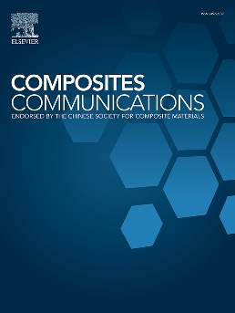
Contacts:
Web of Science Researcher ID: https://www.webofscience.com/wos/author/record/CAA-5342-2022
ORCID ID: 0000-0002-2126-7295
Scopus Author ID: 57190169284
Google Scholar ID: https://scholar.google.co.in/citations?user=jfVyeVsAAAAJ
Publons:
Vidwan ID: 140335
College profile: https://www.nitjsr.ac.in/people/profile/ME145#

Research Team
Doctoral Thesis: 03 Awarded; 1 Submitted; 07 Ongoing
Master’s Thesis: 5 Completed; 01 Ongoing
Bachelor’s Thesis: 13 Completed

Doctoral candidates (ongoing)
- Zahid Mukhtar; Date of joining: June 2022.; status: ongoing; research area: Functionally graded coatings/BioMaterials
- Basant Lal; Status: Completed; Research Area: Ti6Al4V/TiC composites/Biomaterials
- Rohit Bharti; Status: Completed; Research area: Radar Absorbing Coatings/ Military stealth Applications
- Khurshed Ahmad Sheikh; Status: Completed; Research area: Metal matrix comosites
- Uzma Iqbal; Status: ongoing; month of joining: June 2023; Research area: FSP of Magnesium alloys.
- Zahoor ahmad Ahanger; Status: ongoing; month of joining: June 2023; research area: composites coating/BioMaterials
- Tauseef Abdullah; Status: ongoing; month of joining: June 2023; Research area: Ti6Al4V matrix composite processed by powder bed Fusion (PBF)/ Metal additive manufacturing
- Saikat Mandal: Status: ongoing; month of joining: Jan 2026; Research area: DMLS/ Metal additive manufacturing
- Gigasga ; Status: ongoing; month of joining: Jan 2025; Research area: Radar Absorbing Coatings
- Prasant Sourav; Status: ongoing; month of joining: June2025; Research area: Biomaterials/Ti6AL4V alloys
- Subhodip Sukal; Status: ongoing; month of joining: Jan 2026; Research area: Radar Absorbing Coatings

Rohit Bharti | 
Tauseef abdullah | 
Uzma Iqbal | 
Zahid Mukhtar | 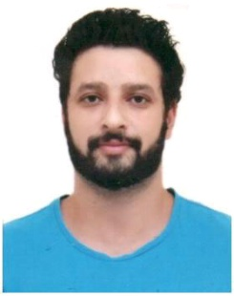
Basant lal | 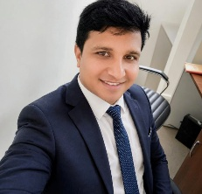
Subhodip sukal | 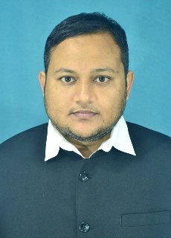
Prasant Sourav | 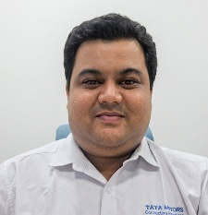
Gigasha mukharjee
Saikat Mondal
Zahoor Ahanger
Khurshad anmad sheikh

Research Interest
- Machinability of Composites
- Biomaterials
- Thin films and coatings for implant applications
- Radar-absorbing coatings

Projects
4.

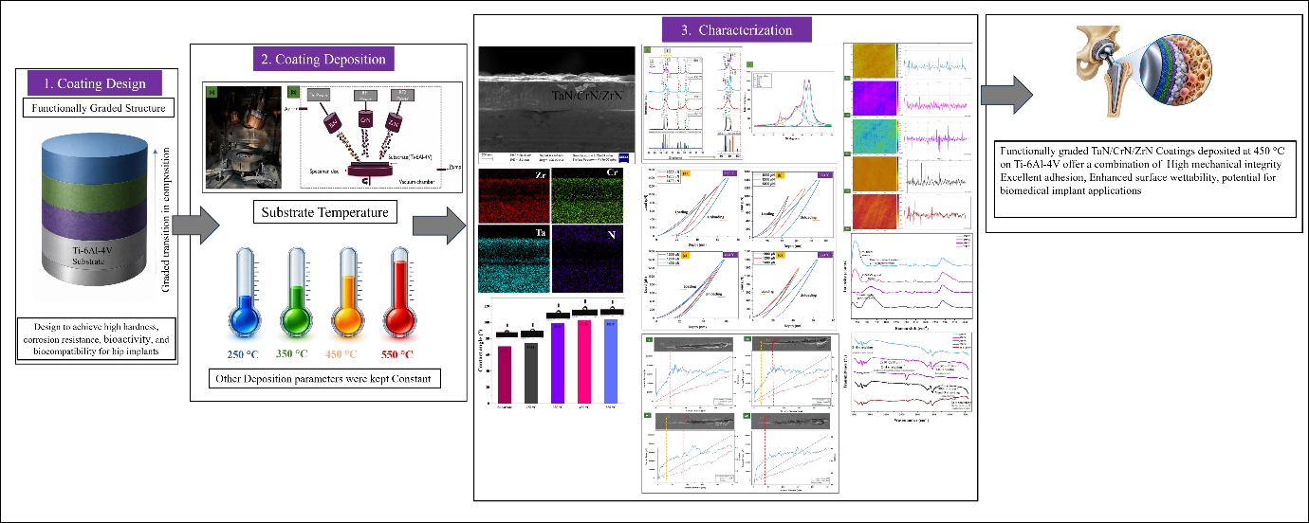
Gradient coatings for Bio medical applications (3)
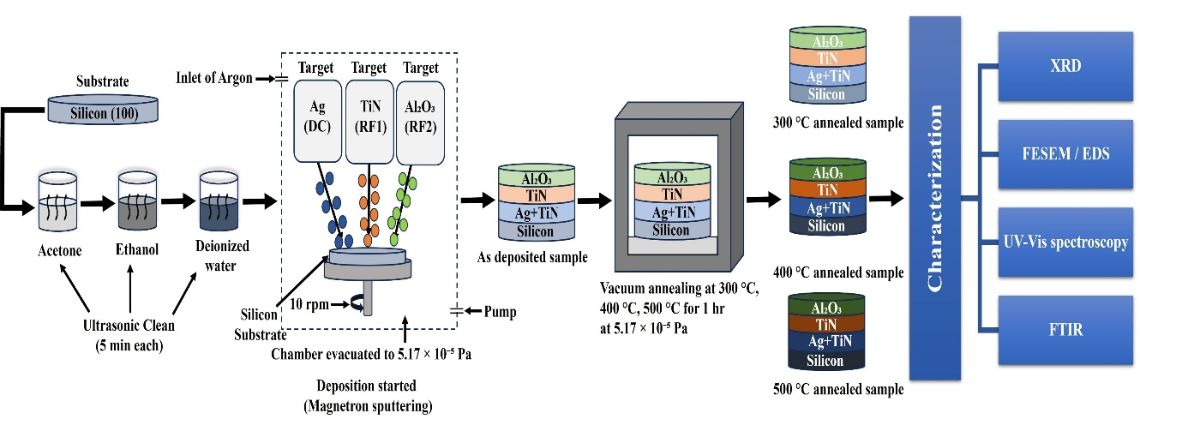
Development and characterizations of Ceramic based RAC(4)
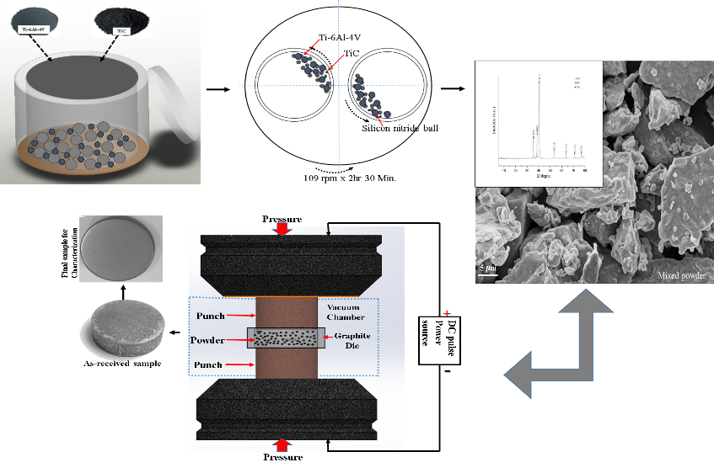
Development and characterization of Bio implant Materials (2 )

